EE4212 Computer Vision

Assignment 2: Markov Random Field and Graphcuts

Name : Emerson Raja Jose Peeterson

Matric. No. : A0195021N/E0383686

**Part 1 : Noise Cleaning**

Remove pepper noise in MRF image below using binary graphcuts.

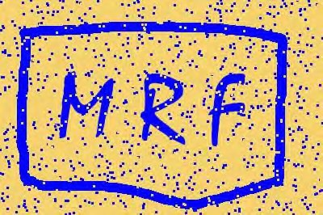

The code part1.m implements this algorithm. The results for different m_lambda are shown below.

m_lambda = 16

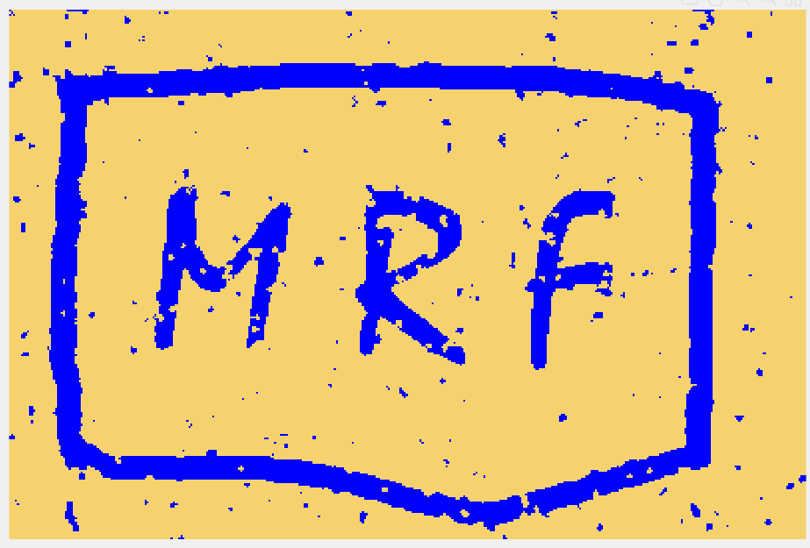

m_lambda = 20

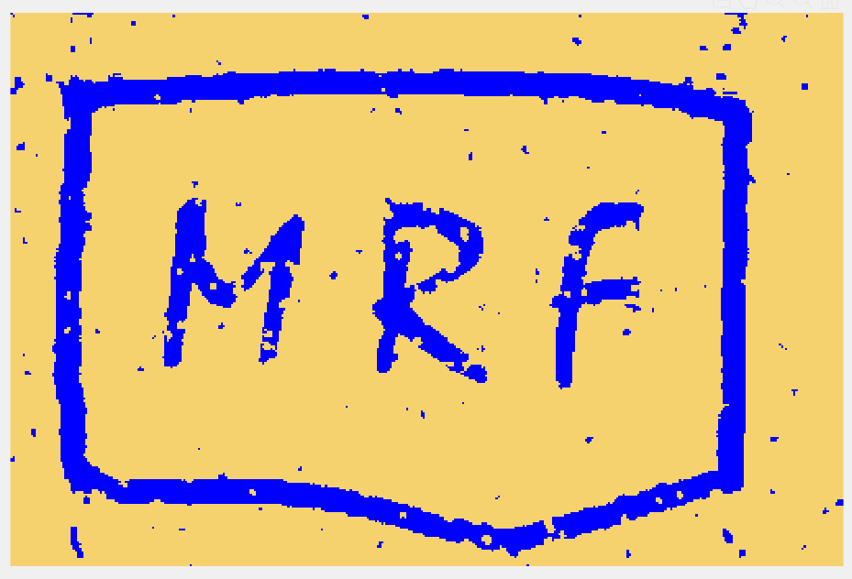

m_lambda = 25



**m_lambda = 30 (Best result)**

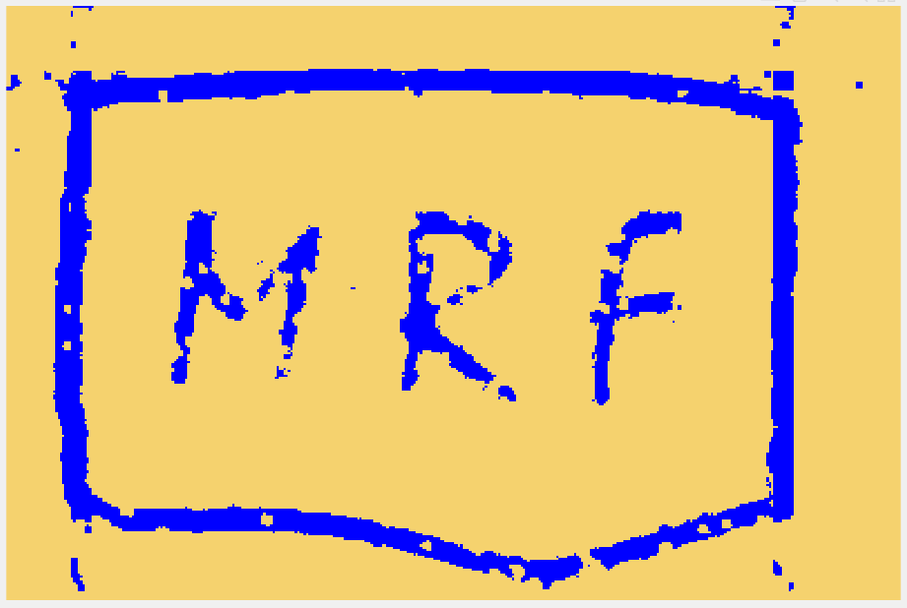

m_lambda = 35

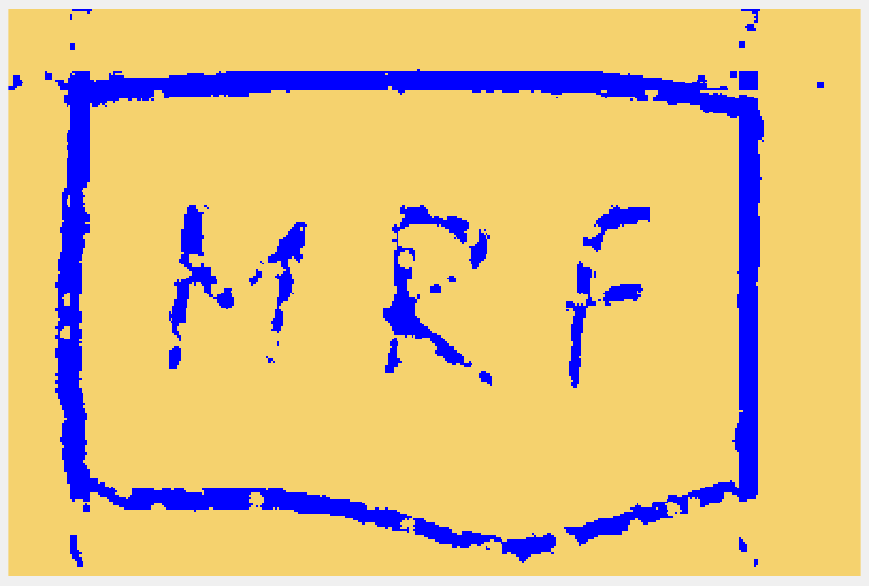

m_lambda = 40

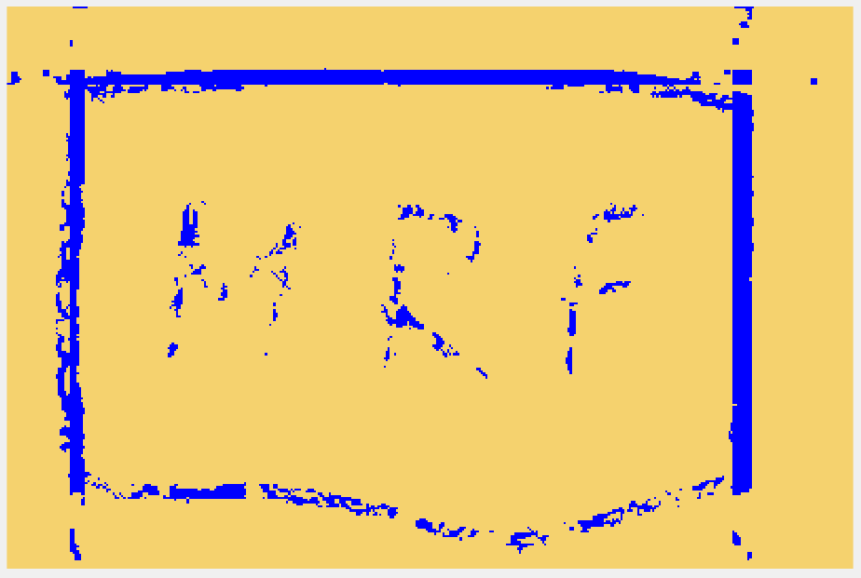

The best m_lambda value lies between 30 and 35 without treating the blue colour MRF and the outline. A good result can be considered as m_lambda = 30 as shown above.

**Part 2: Colour Segmentation**

The code part2.m implements K-means clustering to obtain k number of segmented colours followed by building covariance matrix.

The results are shown below.

Original image

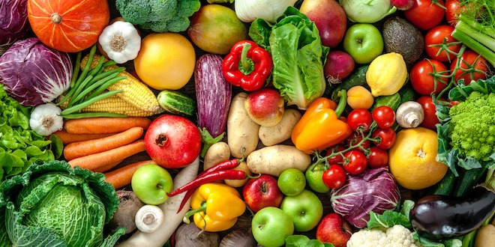

Segmentation results for k = 2

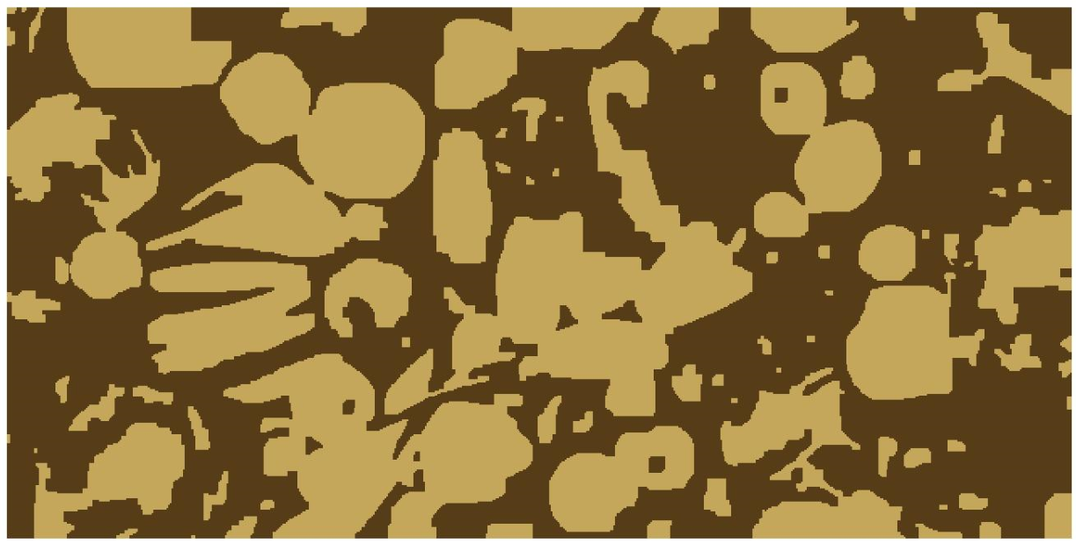

Segmentation results for k = 3

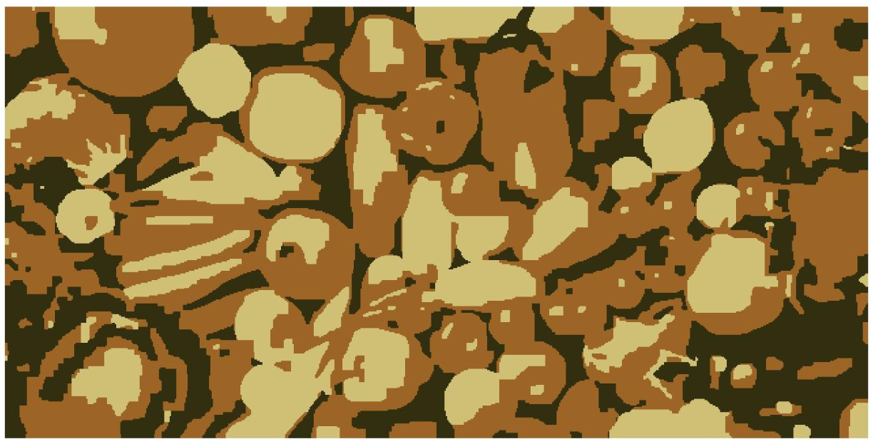

Segmentation results for k = 4

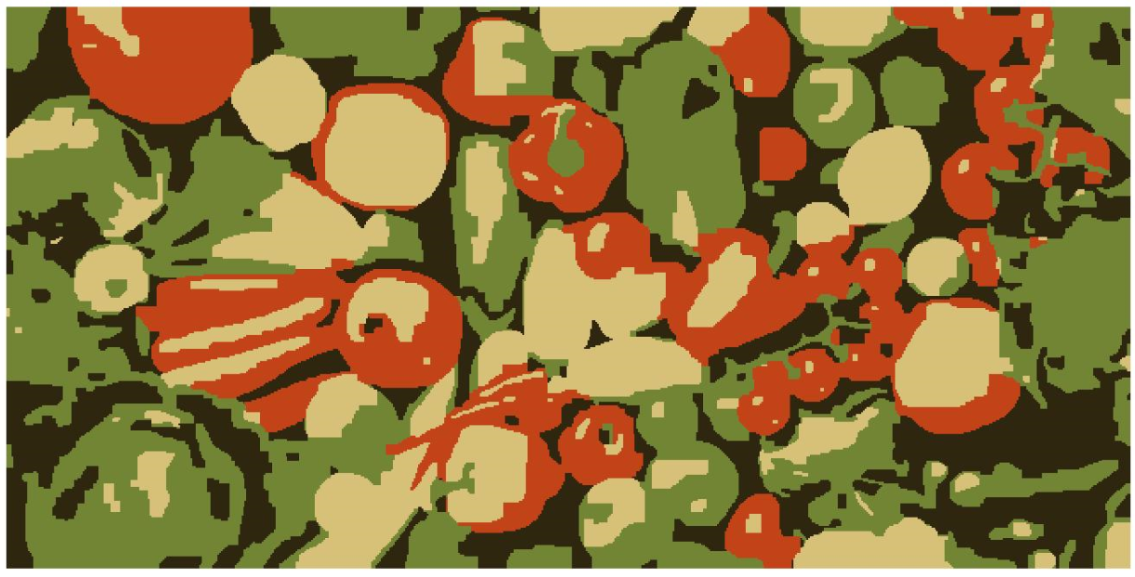

Segmentation results for k = 8

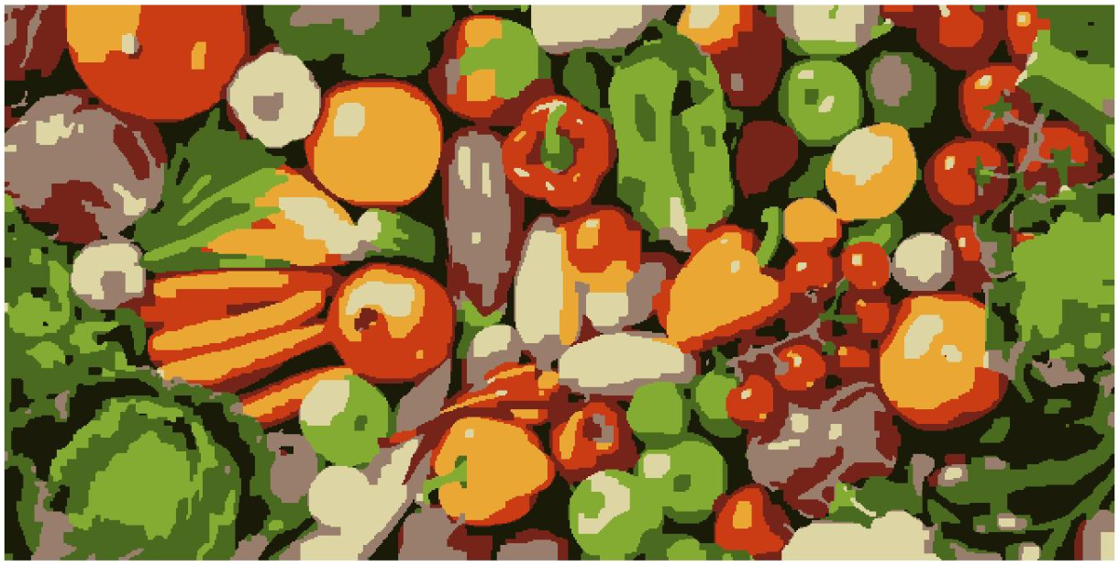

Segmentation results for k = 15

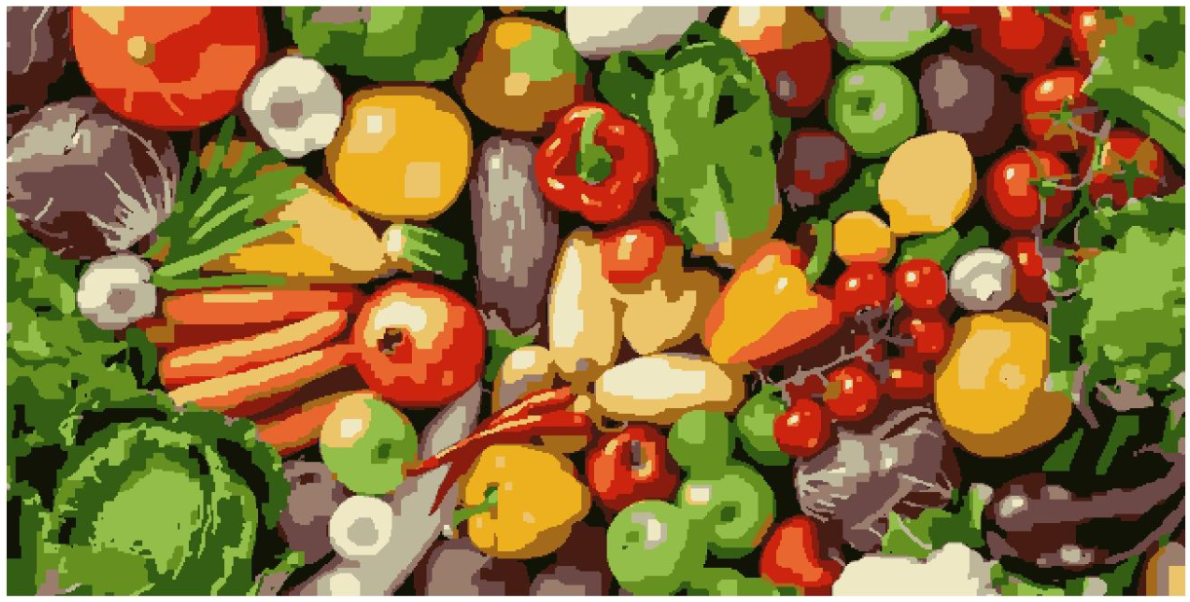

Segmentation results for k = 25

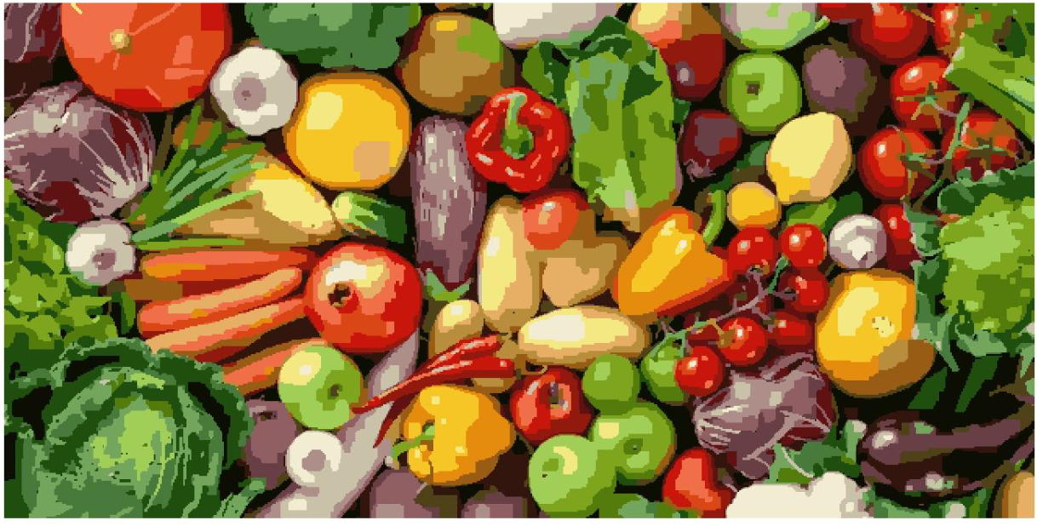

**Drawbacks of the algorithm**

1. Time consumption is high as the k centers become larger even though sparse matrix was used. The problem is computationally difficult (NP-hard);
2. K-means can converge to a “local minimum” not always the global minimum. It only detects spherical clusters only.
3. The problem with K-means clustering is that it is highly sensitive to initial choice of random k center points. For example, k_clusters = 3 when run twice gives a slightly different result as shown by red circles below. It is also sensitive to outliers.

Run 1

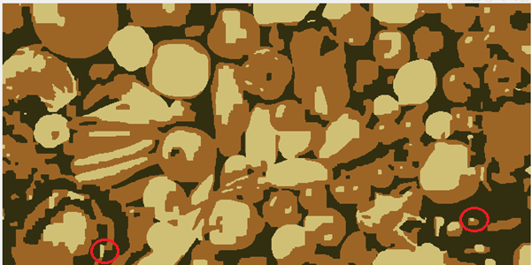

Run 2

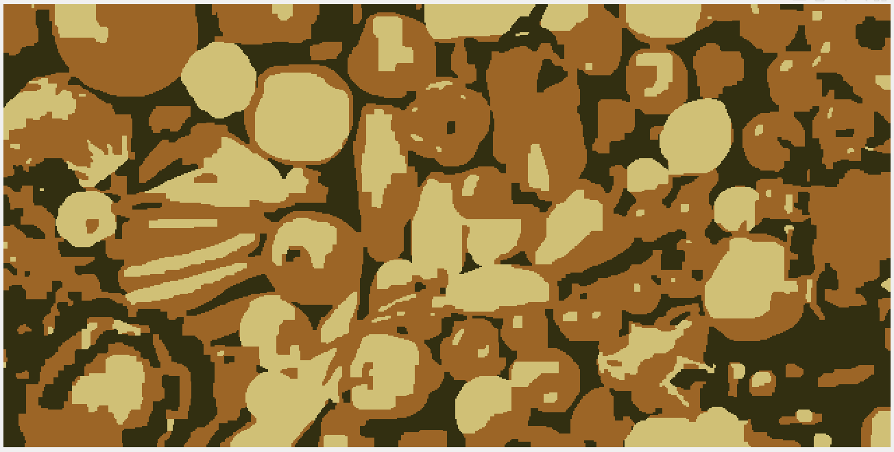

1. Even with efficient graph cuts, an MRF formulation has too many nodes for interactive results.

**Suggestions to improve the algorithm**

1) Use alpha-expansion moves to speed up.

2) Use mean-shift which is Model-free, does not assume any prior shape (spherical etc.) on data clusters. It is just a single parameter (window size h). h has a physical meaning (unlike k-means). It finds variable number of modes and it is robust to outliers

2) We can use K-means++ algorithm to prevent arbitrarily bad local minima because it picks new centers with probability proportional to SSD of pixels.

4) We can use tricks like Superpixels to group together similar‐looking pixels for efficiency of further processing. It is computationally cheap, local oversegmentation.

Appendix

Segmentation results for k = 3

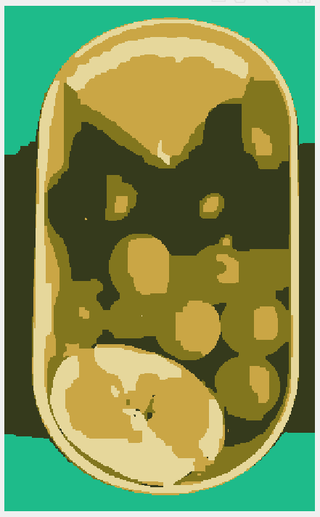

Segmentation results for k = 12

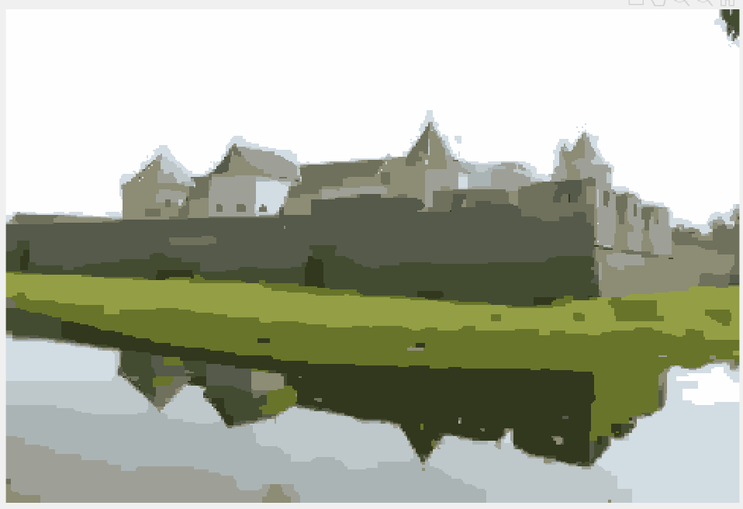

Segmentation results for k = 12

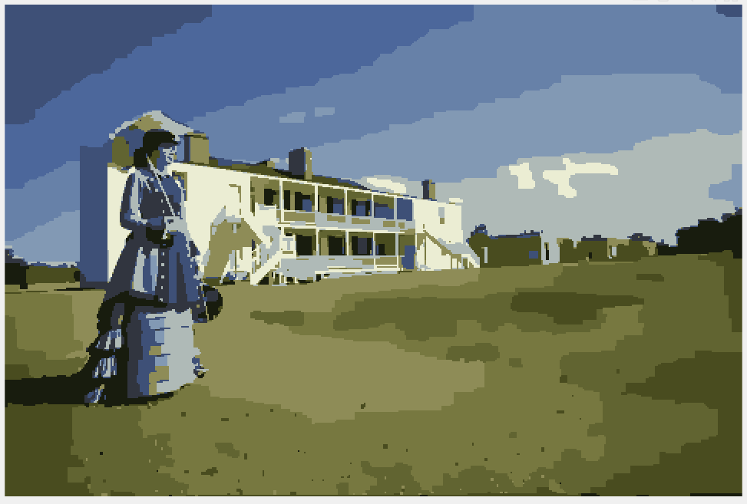

Segmentation results for k = 12

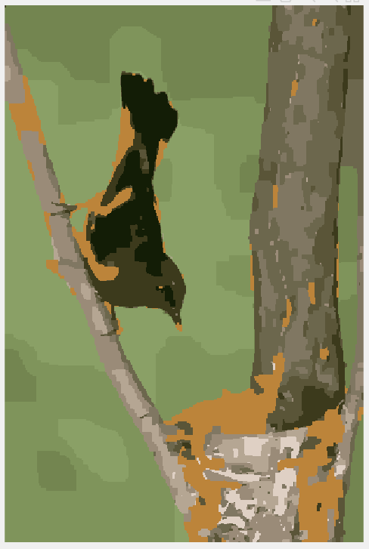

Segmentation results for k = 12



Segmentation results for k = 12

